# Arduino Sensor Data Collection in Microsoft Excel in Real Time

Contents

[Arduino Sensor Data Collection in Microsoft Excel in Real Time 1](#_Toc444913601)

[Parts List 2](#_Toc444913602)

[Instructions. 4](#_Toc444913603)

[Theory behind the code: 5](#_Toc444913604)

[Practical: 6](#_Toc444913605)

## Parts List

|  |  |
| --- | --- |
| Part | Image |
| Arduino (UNO can be used. In this example we are using the Arduino Ethernet Shield POE). | C:\Users\Rabbani\SkyDrive\George Brown\Capstone\Documentation\Images\IMG_20141212_210016.jpg |
| UART | C:\Users\Rabbani\SkyDrive\George Brown\Capstone\Documentation\Images\IMG_20141212_210055.jpg |
| Temperature and Humidity Sensor |  |
| Motion sensor |  |
| Sound sensor |  |
| Wires | C:\Users\Rabbani\SkyDrive\George Brown\Capstone\Documentation\Images\IMG_20141213_052959.jpg |

# Instructions.

1. Set up the circuit as shown below:

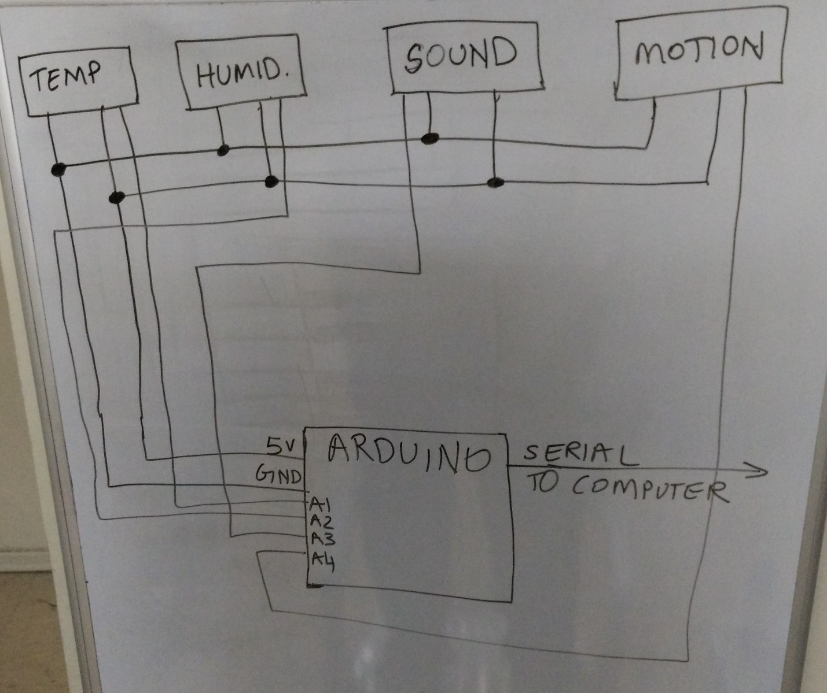

1. Upload the code on <https://github.com/shafeeqr2/Arduino-Sensor-Data-Collection-in-MS-Excel.git> onto an Arduino board. Compile and run the sketch.
2. Install PLX-DAQ from:

<http://www.parallax.com/downloads/plx-daq>

1. Start running the code. Open up the PLX-DAQ spreadsheet, select the baud rate and the COM Port. Click connect so that data can automatically be entered into excel. Graphs made on the data will automatically be updated in real time!

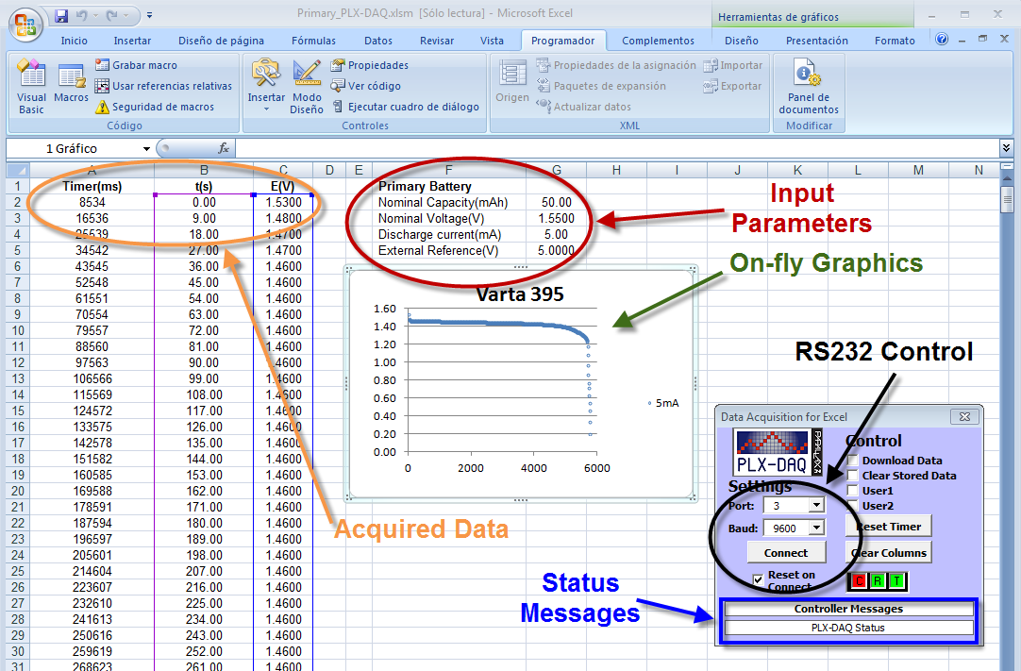

## Theory behind the code:

All phidget sensors send an analog value to the Arduino with the exception of the motion sensor. The motion sensor sends a Boolean. Unlike Big Data, this project has centered on collecting data only when a significant change has been registered. In this regard, the difference ranges shown above have been carefully selected so that the tiny fluctuations do not indicate a change in value and at the same time the sensor’s sensitivity wasn’t reduced to the point where values would be compromised. Data is transferred into the computer through the Serial link.

## Practical:

All sensors worked perfectly. The system was left running overnight on multiple occasions and judging by the timestamps, sensors showed no indication of malfunction.

